Request 1

EXP: It will show employee that has first name Florence and Email FWILKINS if it exists.

SELECT * FROM Employees WHERE First_Name ='Florence'

AND Email = 'FWILKINS'



Request 2

EXP: It will show that employees that have salary 23000 and employees with salary 14990.

SELECT * FROM Employees WHERE Annual_Salary = 23000.00 OR Annual_Salary = 14990.00



Request 3

EXP: Just employee with employee number 182.

SELECT * FROM Employees WHERE Employee_No = 182



Request 4

EXP: Every employee except employee with Employee Number 182.

SELECT * FROM Employees WHERE Employee_No != 182

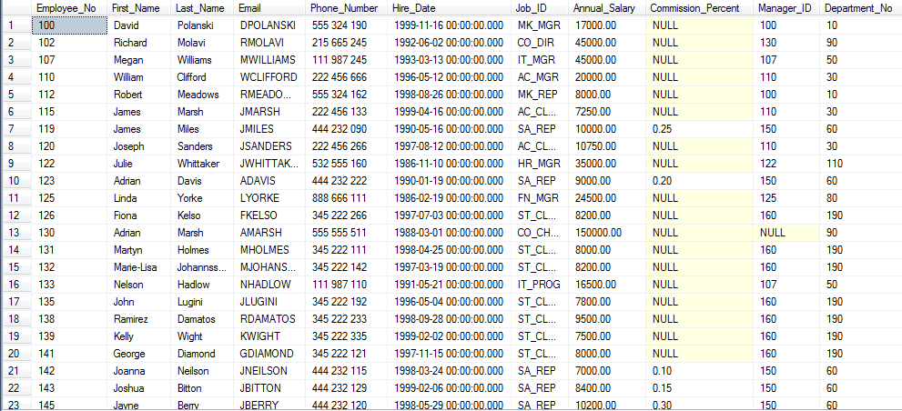

Request 5

EXP: Every employee that has last name starting with letter S.

SELECT Last_Name, First_Name, Employee_No FROM Employees WHERE Last_Name LIKE 'S%'



Request 6

EXP: Diamond, George, 141 etc. Everybody that are hired before or on 26-08-1998 like stock clerk.

SELECT e.Last_Name, e.First_Name, e.Employee_No FROM Employees e

JOIN Jobs j ON e.Job_ID = j.Job_ID

WHERE Hire_Date <= '1998-08-26' AND j.Job_Title = 'Stock Clerk'

ORDER BY Last_Name ASC

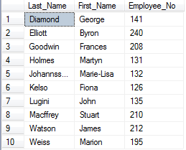

Request 7

EXP: 50, Betteridge, 17500.00 etc. Everbody that are hired between 1998-11-15 and 1999-12-07.

SELECT Department_No, Last_Name, Annual_Salary FROM Employees

WHERE Hire_Date BETWEEN '1998-11-15' AND '1999-12-07'

ORDER BY Last_Name ASC

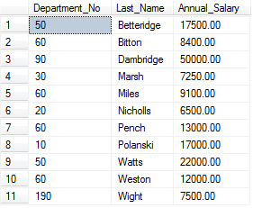

Request 8

EXP: Bitton, Sales Representative, 0.15 etc. with Commission Percentage equal or less then 0.15.

SELECT e.Last_Name, j.Job_Title, e.Commission_Percent FROM Employees e

JOIN Jobs j ON e.Job_ID = j. Job_ID

WHERE e.Commission_Percent <= 0.15

ORDER BY e.Commission_Percent DESC

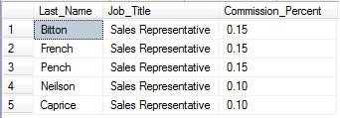

Request 9  
  
EXP: Everything from table Jobs, with max salary begins from smallest to biggest number.

SELECT Job_Title FROM Jobs ORDER BY Max_Salary ASC

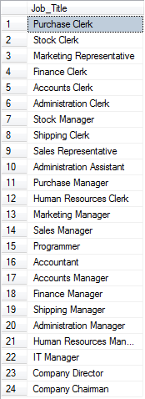

Request 10  
  
EXP: Department Number: 01, 02, etc.

Department Name: D1, D2, etc.

SELECT d.Department_No, d.Department_Name FROM Departments d

WHERE d.Department_No NOT IN

(

SELECT e.Department_No FROM Employees e

JOIN Departments d ON e.Department_No = d.Department_No

JOIN Jobs j ON e.Job_ID = j.Job_ID

AND j.Job_Title = 'Sales Representative'

)

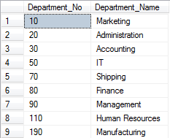

Request 11

EXP: Country_ID: FR, GE, etc.  
Country_Name: France, Germany, etc.

Region_ID: 3, 2, etc.  
  
SELECT * FROM Countries ORDER BY Country_ID ASC

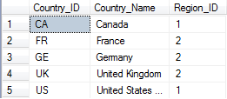

Request 12

EXP: If minimum salary was 8500 now will be 9000.

UPDATE Jobs SET Min_Salary += 500

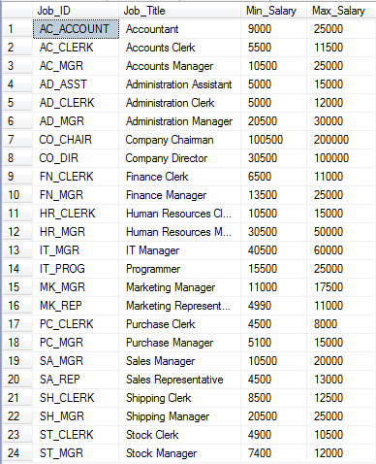

Request 13

EXP: Number

SELECT COUNT(*) AS Total_Number_of_Employees FROM Employees e

JOIN Departments d ON e.Department_No = d.Department_No

WHERE d.Department_Name = 'Finance'



Request 14

EXP: Job_ID : SA_CLERK, Job_Title: Sales Clerk, Min_Salaray: 9000, Max_Salary: 12000 in table Jobs.

INSERT INTO Jobs VALUES ('SA_CLERK', 'Sales Clerk', 9000, 12000)

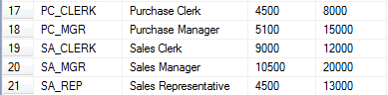

Request 15

1. EXP: Employee with Employee Number 104 will no longer be in table Job_History

DELETE FROM Job_History WHERE Employee_No = 104

1. EXP: Employee Number: 10, 15, 17, etc.  
   Start Date, End Date, Job ID, Department Number

SELECT * FROM Job_History ORDER BY Employee_No ASC

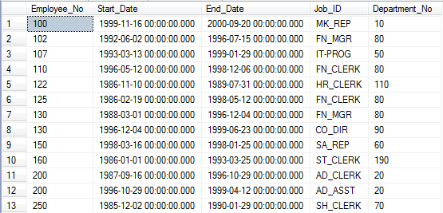

Request 16

EXP: Table with name SAL_History, and columns: EMPID, FIRSTNAME, LASTNAME, HIREDATE, SAL

CREATE TABLE SAL_History

(

EMPID INT PRIMARY KEY NOT NULL,

FIRSTNAME VARCHAR (20) NULL,

LASTNAME VARCHAR (25) NOT NULL,

HIREDATE DATETIME NOT NULL,

SAL DECIMAL (8, 2) NULL

)

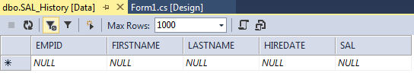

Request 17

EXP: Number

SELECT CAST(ROUND(AVG(Annual_Salary), 2) AS decimal (8,2)) FROM Employees

